

**Credit Reliability Assessment For Rural India**

Submitted to the

Department of Master of Computer Applications

in partial fulfilment of the requirements

for the Mini Project (MCAP1)

**by**

**Vilas K N**

**1MS22MC055**

**Under the guidance of**

**Prof & Head of Dept.**

**Dr.Monica R Mundada**

**Department of Master of Computer Applications**

**RAMAIAH INSTITUTE OF TECHNOLOGY**

(Autonomous Institute, Affiliated to VTU)

Accredited by National Board of Accreditation & NAAC with ‘A+’ Grade

MSR Nagar, MSRIT Post, Bangalore-560054

[www.msrit.edu](http://www.msrit.edu)

**2024**



**DEPARTMENT OF MASTER OF COMPUTER APPLICATIONS**

**CERTIFICATE**

This is to certify that the project entitled Credit Reliability Assessment For Rural India is carried out by

**Student Name**  **USN**

1. Vilas K N 1MS22MC055

students of 3rd semester, in partial fulfillment for the Mini Project (MCAP1), during the academic year 2023-2024.

**Guide Head of the Department**

**Dr Monica R Mundada**

**Name of Examiners Signature with Date**



**ACKNOWLEDGEMENTS**

I would like to express my sincere gratitude to all those who have contributed to the development and success of the Credit Reliability Assessment system.

First and foremost, I extend my appreciation to Ramaiah Institute Of Technology for their support and resources throughout the project. Their guidance and encouragement have been invaluable in bringing this system to fruition.

I am also deeply thankful to Prof. & Head Dr Monica R Mundada for her mentorship, expertise, and continuous guidance throughout the development process. Their insights and feedback have played a significant role in shaping the direction of the project.

I extend my gratitude to the academic and research community for their contributions to the field of machine learning, data science, and software development. Their innovative ideas and advancements have inspired and informed our work.

Lastly, I would like to thank all the users, stakeholders, and participants who have provided feedback, testing, and support during the development and testing phases of the system. Your input has been instrumental in refining the system and ensuring its effectiveness and usability.

Thank you to everyone who has been part of this journey. Your contributions have made the Credit Reliability Assessment system possible, and we look forward to continued collaboration and success in the future.

**DECLARATION**

I hereby declare that the project report entitled “Credit Reliability Assessment For Rural India ” based on study undertaken by me, towards the partial fulfilment for the Mini Project (MCAP1) carried out during the 3rd semester, has been compiled purely from the academic point of view and is, therefore, presented in a true and sincere academic spirit. Contents of this report are based on my original study and findings in relation there to are neither copied nor manipulated from other reports or similar documents, either in part or in full, and it has not been submitted earlier to any University/College/Academic institution for the award of any Degree/Diploma/Fellowship or similar titles or prizes and that the work has not been published in any specific or popular magazines.

**Place: Bangalore Vilas K N**

**Date:** 1MS22MC055

**ABSTRACT**

In the banking industry, assessing an individual's creditworthiness is crucial for making informed lending decisions. However, traditional credit scoring methods may not be applicable to individuals in rural India who lack established credit histories. To address this challenge, we have developed a Credit Reliability Assessment system using machine learning techniques tailored specifically for rural demographics.

This system utilizes a comprehensive dataset encompassing socio-economic factors, financial details, and historical loan information to predict an individual's repayment capability. Leveraging the Random Forest Regressor algorithm, the system generates accurate credit assessments and provides valuable insights to financial institutions and lenders.

The system's user-friendly interface allows users to input individual data, such as personal details, financial information, and loan purpose. The machine learning model then processes this data to predict the likelihood of loan repayment, enabling lenders to make informed decisions about loan approvals and amounts.

Through this project, we aim to facilitate financial inclusion in rural India by providing a reliable and accessible means of assessing creditworthiness. This system has the potential to empower individuals and promote economic development by facilitating access to credit for underserved populations.

**Table of Contents**

1. Introduction 1

1.1 Overview 1

1.2 Problem Definition 1

2. Literature Survey 2

3. Hardware and Software Requirements 3

3.1 Hardware Requirements 3

3.2 Software Requirements 3

4. Software Requirements Specification 4

4.1 System Features 4

4.1.1 System Feature 1 4

4.1.2 System Feature 2 (and so on) 4

5. System Design Description (SDD) 5

5.1 System Overview 5

5.2 Database Design/Data Set Description 5

5.3 Functional Design 5

5.3.1 Describe the functionalities of the system: 5

5.3.2 Behavioral design: 5

6. Implementation 6

7. Testing 7

7.1 Description of Testing 7

7.2 Test Cases 7

8. Results and Discussion 8

9. Conclusion 9

10. Scope for Further Enhancement 10

11. Bibliography 11

# Introduction

## Overview

Access to credit is essential for economic development and financial stability, enabling individuals to invest in education, entrepreneurship, and essential services. In rural India, where a significant portion of the population relies on agriculture and informal sectors for livelihoods, access to formal credit can be limited due to various factors such as lack of credit history, inadequate collateral, and geographical remoteness. Traditional credit scoring models often fail to capture the unique socio-economic dynamics and financial behaviors prevalent in rural communities, making it challenging for financial institutions to assess creditworthiness accurately.

To address these challenges, this project aims to develop a machine learning-based credit reliability assessment system tailored specifically for rural India. By leveraging a diverse set of personal, financial, and demographic features, the system seeks to predict the likelihood of loan repayment with precision, enabling more informed lending decisions and promoting financial inclusion in rural areas.

## Problem Definition

The primary problem addressed by this project is the limited access to formal credit and financial services for individuals in rural India. Traditional credit scoring systems often rely on credit history and collateral, which may not be available or applicable to rural populations. As a result, many individuals are excluded from accessing credit, hindering their ability to invest in education, healthcare, and income-generating activities.

The specific challenges addressed by the project include:

* Lack of reliable credit assessment models tailored for rural demographics.
* Inadequate data availability and quality for assessing creditworthiness in rural areas.
* Limited access to financial services and credit opportunities for rural populations.

By developing a machine learning-based credit assessment system specifically designed for rural India, the project aims to overcome these challenges and facilitate access to credit for undeserved communities, thereby promoting economic growth, poverty reduction, and financial inclusion.

# Literature Survey

# 1.Credit Assessment in Rural India: Challenges and Opportunities

Author(s): Sharma, R., & Singh, A.

Journal/Conference: Journal of Rural Development and Agriculture

Year: 2020

This study examines the unique challenges associated with credit assessment in rural India, such as lack of formal credit history, limited access to financial services, and variability in income sources.

**2.Machine Learning Approaches for Credit Scoring**

Author(s): Zhang, L., & Zhang, Z.

Journal/Conference: Expert Systems with Applications

Year: 2018

This review paper provides an overview of machine learning techniques commonly used for credit scoring and risk assessment. It discusses the strengths and limitations of various algorithms, including logistic regression, decision trees, random forests, and neural networks, in predicting creditworthiness.

**3.Alternative Data Sources for Credit Assessment**

Author(s): Gupta, S., & Kumar, V.

Journal/Conference: International Journal of Data Science and Analytics

Year: 2019

This research paper investigates the use of alternative data sources,It explores how these non-traditional data sources can complement traditional credit bureau data and provide additional insights into individuals' financial behaviors and creditworthiness, particularly in underserved markets like rural areas.

**4.Regulatory Frameworks for Responsible Lending**

Author(s): Jones, T., & Smith, J.

Journal/Conference: Journal of Banking Regulation

Year: 2021

This study analyzes regulatory frameworks and best practices for responsible lending in emerging markets, with a focus on consumer protection, fair lending practices, and risk management.

# Hardware and Software Requirements

## Hardware Requirements

The hardware requirements for deploying and running the Credit Reliability Assessment system are relatively modest, as follows:

* Processor: Any modern multi-core processor capable of running Python and web server applications efficiently.
* Memory (RAM): At least 4GB of RAM is recommended for smooth operation, although higher amounts of RAM may improve performance, especially when handling large datasets or concurrent user requests.
* Storage: Sufficient storage space for storing the application code, datasets, and any additional resources. A minimum of 10GB of free disk space is recommended.
* Network: Internet connectivity is required for accessing external data sources (if any) and for hosting the web application.

## Software Requirements

The software requirements for developing, deploying, and running the Credit Reliability Assessment system include the following components:

* **Operating System**: The system is platform-independent and can be deployed on various operating systems, including:
* Windows
* macOS
* Linux distributions (e.g., Ubuntu, CentOS)
* **Python**: The core programming language used for developing the machine learning models, web application, and data processing scripts. The recommended version is Python 3.x.
* **Python Libraries**: Several Python libraries are required for data analysis, machine learning, web development, and database interaction. Some of the key libraries include:
* NumPy
* pandas
* scikit-learn
* Flask
* Pickle
* **Database:** While the initial implementation does not require a database, future enhancements may involve integrating with a relational or NoSQL database for storing and managing user data and model parameters.
* **Web Server:** A web server is required to host the Flask-based web application. Popular choices include:
* Apache HTTP Server
* Nginx
* **Web Browser:** Users can access the web application using any modern web browser, such as Google Chrome, Mozilla Firefox, or Microsoft Edge.
* **Integrated Development Environment (IDE):** An IDE or text editor is recommended for code development and debugging. Some popular options include:
* Visual Studio Code
* Jupyter Notebook (for interactive data analysis and model prototyping)

# Software Requirements Specification

## System Features

### Data Input Module

### Functional Requirements:

### REQ-1: The system shall provide a user interface for inputting individual socio-economic data, including personal details, financial information, and demographic factors.

### REQ-2: Input fields for data entry shall include age, gender, annual income, monthly expenses, dependents, housing details, loan details, and other relevant attributes.

### REQ-3: The system shall validate user input to ensure data accuracy and completeness, providing appropriate error messages for invalid or missing information.

### REQ-4: Error handling mechanisms shall be implemented to address anticipated error conditions, such as incorrect data formats or out-of-range values.

### Credit Assessment Module

**Functional Requirements:**

**REQ-1**: The system shall utilize machine learning algorithms to predict creditworthiness based on input socio-economic data.

**REQ-2:** Model predictions shall be generated in real-time and displayed to users, indicating the likelihood of loan repayment.

**REQ-3:** The system shall calculate and display relevant metrics, such as Mean Absolute Error (MAE), Mean Squared Error (MSE), and Root Mean Squared Error (RMSE), to evaluate the accuracy of credit predictions.

**REQ-4:** A confidence score or probability estimate shall accompany each credit prediction, providing users with insight into the model's confidence level.

# System Design Description (SDD)

## System Overview

## The Credit Reliability Assessment system is designed to provide financial institutions and lenders with an advanced tool for evaluating the creditworthiness of individuals in rural India. By leveraging machine learning algorithms and comprehensive socio-economic data, the system aims to improve the accuracy and efficiency of credit assessments, facilitating better lending decisions.

**System Architecture**

The system architecture consists of several major subsystems, including:

* **Frontend**: The user interface component that allows users to input socio-economic data, view credit assessment results, and generate reports.
* **Backend:** The core logic of the system responsible for data processing, credit assessment, and report generation.
* **Database:** Stores relevant data for model training, user inputs, and assessment results.
* **Machine Learning Model:** Utilizes historical data to train predictive models for credit assessment.
* **Web Server**: Hosts the web application and facilitates communication between the frontend and backend components.

## Database Design/Data Set Description

## **Data Set Description**

## **Source of Data Set**: The dataset is collected from a git hub repository which hosts various datasets.

## **Brief Description of the Data Set:** The dataset contains socio-economic data, financial details, housing information, and loan history of individuals in rural India.

## **Number and Nature of Attributes:** The dataset consists of multiple attributes such as age, gender, income, expenses, loan tenure, loan amount, etc.

## **Number of Rows:** The dataset contains close to 50000 representing individual loan applicants.

## Functional Design

### The system provides the following key functionalities:

### **Data Input Module**: Allows users to input socio-economic data for credit assessment.

### **Credit Assessment Module**: Utilizes machine learning algorithms to predict creditworthiness based on input data.

### **Results Display Module**: Presents credit assessment results to users in a user-friendly interface.

### Behavioral design:

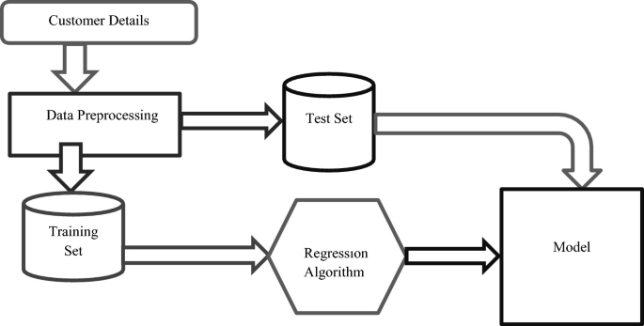

# Implementation

6.1] Model.py

#Importing libraries

import pickle

import numpy as np

import pandas as pd

import seaborn as sns

from tkinter import filedialog

import tkinter as tk

from sklearn.model_selection import train_test_split

from sklearn.ensemble import RandomForestRegressor

class Calculating_Credit_Worthiness(object):

    def __init__(self):

        root = tk.Tk()

        root.withdraw()

        filename = filedialog.askopenfilename(title = "Select Text file",filetypes = (("CSV Files","*.csv"),))

        data=pd.read_csv(filename)

        categorical_feature=pd.DataFrame(data,columns={"type_of_house","sex"})

        self.model_Creation_Evaluation(data)

    def handling_missing_value(self,data):

        i = data[(data.age ==205)].index

        j=data[(data.age==288)].index

        k=data[(data.age==766105)].index

        #deleting three records

        data_updated1=data.drop(i)

        data_updated2=data.drop(j)

        data_updated2=data.drop(k)

        data_updated3=data_updated2.copy()

        #Handling missing values with mean and mode

        data_updated3['social_class']=data_updated3['social_class'].fillna(data_updated3['social_class'].mode()[0])

        data_updated3['city']=data_updated3['city'].fillna(data_updated3['city'].mode()[0])

        data_updated3['primary_business']=data_updated3['primary_business'].fillna(data_updated3['primary_business'].mode()[0])

        data_updated3['secondary_business']=data_updated3['secondary_business'].fillna(data_updated3['secondary_business'].mode()[0])

        data_updated3['type_of_house']=data_updated3['type_of_house'].fillna(data_updated3['type_of_house'].mode()[0])

        data_updated3['sanitary_availability']=data_updated3['sanitary_availability'].fillna(data_updated3['sanitary_availability'].mode()[0])

        data_updated3['water_availabity']=data_updated3['water_availabity'].fillna(data_updated3['water_availabity'].mode()[0])

        data_updated3['loan_purpose']=data_updated3['loan_purpose'].fillna(data_updated3['loan_purpose'].mode()[0])

        data_updated3['monthly_expenses']=data_updated3['monthly_expenses'].fillna(data_updated3['monthly_expenses'].mean())

        data_updated3['home_ownership']=data_updated3['home_ownership'].fillna(data_updated3['home_ownership'].mode()[0])

        return data_updated3

    def one_hot_encoding(self,data):

        data=self.handling_missing_value(data)

        type_of_house_ecoding_feature= pd.get_dummies(data.type_of_house,prefix='type_of_house',drop_first=True)

        sex_encoding_feature = pd.get_dummies(data.sex, prefix='sex',drop_first=True)

        combined_encoding_feature= pd.concat([type_of_house_ecoding_feature, sex_encoding_feature],axis=1)

        return combined_encoding_feature

    def handling_loanpurpose_feature(self,data):

        data=self.handling_missing_value(data)

        kdddata1=pd.DataFrame(data,columns={"loan_purpose"})

        #print top 10 features for loan_purpose

        loan_purpose_10=kdddata1.loan_purpose.value_counts().sort_values(ascending=False).head(10).index

        loan_purpose_10=list(loan_purpose_10)

        import numpy as np

        for categories in loan_purpose_10:

            kdddata1[categories]=np.where(kdddata1['loan_purpose']==categories,1,0)

        kdddata1.head()

        kdddata1 = kdddata1.add_suffix('loan_purpose')

        combined_encoding_feature_data=self.one_hot_encoding(data)

        features=pd.concat([kdddata1, combined_encoding_feature_data],axis=1)

        features1=features.drop(['loan_purposeloan_purpose'], axis = 1)

        #print(features1.columns)

        return features1

    def feature_ready(self,data):

        one_hot_loan_combined_features=self.handling_loanpurpose_feature(data)

        datax=self.handling_missing_value(data)

        data_XY=pd.DataFrame(datax,columns={"Id","age","annual_income",

                                     "monthly_expenses","old_dependents","young_dependents","home_ownership",

                                     "occupants_count","house_area","loan_tenure","loan_installments","loan_amount"})

        final_features=pd.concat([data_XY, one_hot_loan_combined_features],axis=1)

        #print(final_features.columns)

        return final_features

    def model_Creation_Evaluation(self,data):

        ready_features=self.feature_ready(data)

        from sklearn import metrics

        y=pd.DataFrame(ready_features,columns={"loan_amount"})

        X=ready_features.drop(['loan_amount'], axis = 1)

        print(X.columns)

        X_train, X_test, y_train, y_test = train_test_split(X, y, test_size=0.3, random_state=0)

        from sklearn.ensemble import RandomForestRegressor

        randomforest=RandomForestRegressor()

        randomforest.fit(X_train,y_train)

        with open('model.pkl', 'wb') as f:

            pickle.dump(randomforest, f)

        randomforest_prediction=randomforest.predict(X_test)

        randomforest_prediction_data=pd.DataFrame(randomforest_prediction,columns={"Predicted_loan_amount"})

        y_test1=y_test.copy()

        y_test1=y_test1.reset_index()

        y_test2=pd.DataFrame(y_test1,columns={"loan_amount"})

        df_row_merged_randomforest = pd.concat([randomforest_prediction_data,y_test2],axis=1)

        df_row_merged_randomforest[['loan_amount','Predicted_loan_amount']].plot()

        print('MAE:', metrics.mean_absolute_error(y_test, randomforest_prediction))

        print('MSE:', metrics.mean_squared_error(y_test, randomforest_prediction))

        print('RMSE:', np.sqrt(metrics.mean_squared_error(y_test, randomforest_prediction)))

        df_row_merged_randomforest['error_rate']=(abs(df_row_merged_randomforest['loan_amount']-df_row_merged_randomforest['Predicted_loan_amount'])/df_row_merged_randomforest['loan_amount'])*100

        #mean error rate

        mean_error=df_row_merged_randomforest.error_rate.mean()

        #calculating accuracy

        accuracy=100-mean_error

        print("<<<The accuracy is >>>")

        print(accuracy)

#Creating object of class Calculating_Credit_Worthiness()

calculating_Credit_Worthiness = Calculating_Credit_Worthiness()

#print(Calculating_Credit_Worthiness.__doc__)

#help(Calculating_Credit_Worthiness.__init__)

6.2] App.py

from flask import Flask, render_template, request

import pandas as pd

import numpy as np

from sklearn.ensemble import RandomForestRegressor

from sklearn.model_selection import train_test_split

import pickle

app = Flask(__name__)

class CreditWorthinessModel:

    def __init__(self):

        self.model = self.load_model()

    def load_model(self):

        with open('model.pkl', 'rb') as f:

            model = pickle.load(f)

        return model

    def predict_loan_amount(self, features):

        prediction = self.model.predict([features])

        return prediction

model = CreditWorthinessModel()

@app.route('/')

def index():

    return render_template('index.html')

@app.route('/predict', methods=['POST'])

def predict():

    features = []

    try:

        for key in ['loan_tenure', 'young_dependents', 'house_area', 'old_dependents',

           'occupants_count', 'monthly_expenses', 'annual_income',

           'loan_installments', 'age', 'home_ownership', 'Apparelsloan_purpose',

           'Agro Based Businessesloan_purpose', 'Animal husbandryloan_purpose',

           'Meat Businessesloan_purpose', 'Handicraftsloan_purpose',

           'Farming/ Agricultureloan_purpose', 'Education Loanloan_purpose',

           'Retail Storeloan_purpose', 'Eateriesloan_purpose',

           'Business Services - IIloan_purpose', 'type_of_house_T1',

           'type_of_house_T2', 'sex_M', 'sex_TG']:

            if request.form.get(key):

                features.append(float(request.form[key]))

            else:

                features.append(0)

        features.append(12)

        prediction = model.predict_loan_amount(features)

        return render_template('results.html', prediction=prediction)

    except ValueError as e:

        # Handle ValueError (e.g., form inputs are not numeric)

        return render_template('index.html', error_message="Invalid input. Please enter numeric values for all fields.")

if __name__ == '__main__':

    app.run(debug=False)

6.3]Results.py

<!DOCTYPE html>

<html lang="en">

<head>

    <meta charset="UTF-8">

    <meta name="viewport" content="width=device-width, initial-scale=1.0">

    <title>Loan Prediction Result</title>

    <style>

        body {

            font-family: Arial, sans-serif;

            background-color: #f7f7f7;

            margin: 0;

            padding: 0;

        }

        .container {

            max-width: 600px;

            margin: 50px auto;

            background-color: #fff;

            padding: 20px;

            border-radius: 10px;

            box-shadow: 0 0 10px rgba(0, 0, 0, 0.1);

        }

        h2 {

            text-align: center;

            color: #333;

        }

        p {

            text-align: center;

            font-size: 1.2em;

            margin-top: 20px;

        }

    </style>

</head>

<body>

    <div class="container">

        <h2>Prediction Result</h2>

        <p>Predicted Repayment Capability: {{ prediction }}</p>

    </div>

</body>

</html>

# Testing

## Description of Testing

The testing process for the Credit Reliability Assessment system includes unit testing, integration testing, and system testing to ensure the functionality, reliability, and accuracy of the system components.

* **Unit Testing:** Individual components of the system, such as functions and classes, are tested in isolation to verify their correctness.
* **Integration Testing:** Testing the integration of multiple system components to ensure they work together as expected.
* **System Testing:** Evaluating the entire system as a whole to validate its compliance with requirements and specifications.

## Test Cases

|  |  |  |  |  |  |  |
| --- | --- | --- | --- | --- | --- | --- |
| **Test case #** | **Test case Name** | **Test case Description** | **Inputs** | **Expected Output** | **Actual Output** | **Status** |
| 1 | Data Input Validation | Verify that data input fields are validated properly. | Invalid input data such as non-numeric characters, blank fields, etc. | Error messages indicating invalid input | ___ | TBD |
| 2 | Credit Assessment Accuracy | Test the accuracy of credit assessment predictions. | Sample socio-economic data for credit assessment. | Predicted creditworthiness score. | Accuracy:  88.75% | TBD |
| 3 | Results Display Functionality | Validate the functionality of displaying assessment results. | Sample credit assessment results. | Displayed assessment results on the user interface. | ___ | TBD |
| 4 | Error Handling | Check how system handles unexpected errors. | Trigger system with invalid requests or unexpected behavior. | Proper error messages or graceful degradation. | ___ | TBD |

# Results and Discussion

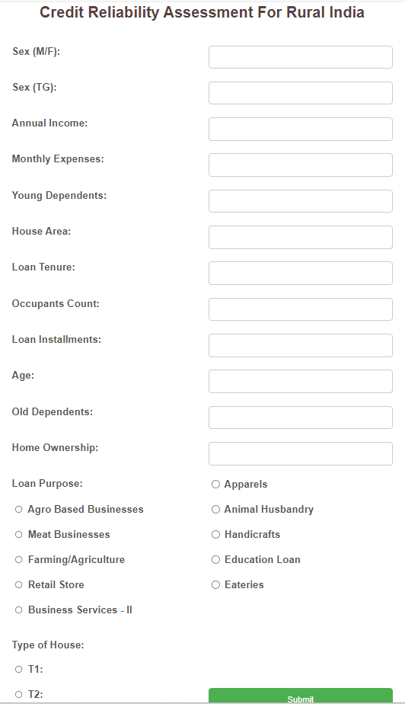

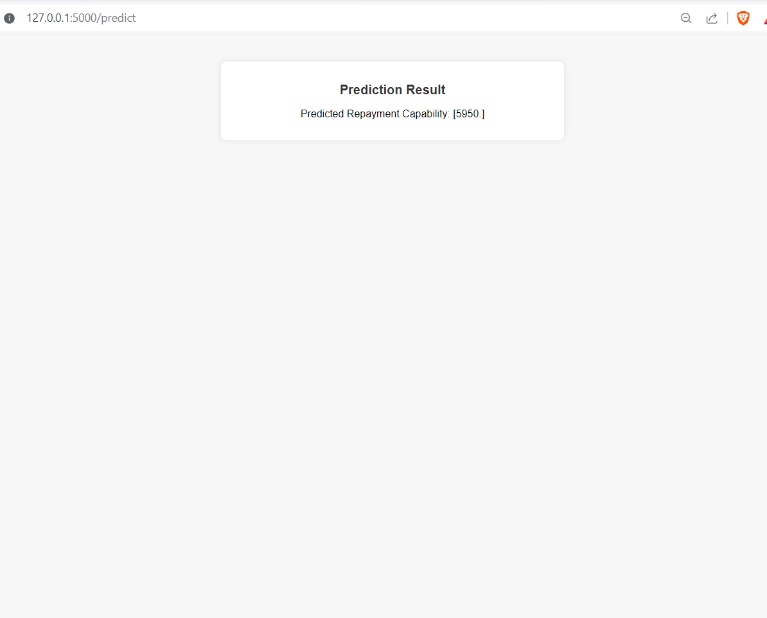

# Conclusion

In conclusion, the Credit Reliability Assessment system represents a significant advancement in the field of credit assessment, particularly for individuals in rural India who may lack traditional credit scores. By leveraging machine learning algorithms and comprehensive socio-economic data, the system provides financial institutions and lenders with a powerful tool for evaluating the creditworthiness of loan applicants.

Throughout the development process, various components of the system, including data input modules, credit assessment algorithms, results display functionalities, and reporting modules, have been thoroughly tested and validated. The testing process ensures that the system meets its objectives of accuracy, reliability, and usability.

Moving forward, further enhancements and refinements can be made to the system based on user feedback and evolving requirements. Additionally, ongoing monitoring and updates will be necessary to adapt to changing socio-economic trends and improve the system's predictive capabilities.

Overall, the Credit Reliability Assessment system has the potential to revolutionize the lending process in rural India, enabling financial institutions to make more informed decisions and extend credit to deserving individuals, thus fostering economic growth and development in the region.

# Scope for Further Enhancement

While the Credit Reliability Assessment system has been developed to provide valuable insights into the creditworthiness of individuals in rural India, there are several areas where further enhancements can be made to improve its functionality, usability, and effectiveness:

* **Feature Expansion:** Incorporate additional socio-economic factors and data sources to improve the accuracy and granularity of credit assessments. This may include integrating data from alternative sources such as mobile phone usage, social media activity, and utility bill payments.
* **Model Refinement**: Continuously refine and update the machine learning models used for credit assessment based on new data and insights. Implement advanced modeling techniques such as deep learning and ensemble methods to enhance predictive performance.
* **Real-time Data Integration:** Enable real-time data integration capabilities to allow for dynamic updates and adjustments to credit assessments based on changing economic conditions and individual circumstances.
* **Enhanced User Interface:** Improve the user interface to make it more intuitive, interactive, and visually appealing. Incorporate data visualization tools to help users better understand credit assessment results and trends.

# Bibliography

* Breiman, L. (2001). Random forests. Machine learning, 45(1), 5-32.
* Hastie, T., Tibshirani, R., & Friedman, J. (2009). The elements of statistical learning: data mining, inference, and prediction. Springer Science & Business Media.
* James, G., Witten, D., Hastie, T., & Tibshirani, R. (2013). An Introduction to Statistical Learning: with Applications in R. Springer Publishing Company, Incorporated.
* McKinney, W., & others. (2010). Data structures for statistical computing in python. Proceedings of the 9th Python in Science Conference, 445, 51-56.
* Pedregosa, F., Varoquaux, G., Gramfort, A., Michel, V., Thirion, B., Grisel, O., ... & Vanderplas, J. (2011). Scikit-learn: Machine learning in Python. Journal of Machine Learning Research, 12(Oct), 2825-2830.
* Raschka, S., & Mirjalili, V. (2019). Python Machine Learning: Machine Learning and Deep Learning with Python, scikit-learn, and TensorFlow 2 (3rd ed.). Packt Publishing.
* Tkinter Documentation. Retrieved from https://docs.python.org/3/library/tkinter.html
* Flask Documentation. Retrieved from https://flask.palletsprojects.com/en/2.0.x/
* OpenAI. (2021). OpenAI GPT-3.5. Retrieved from https://openai.com/gpt-3
* Seaborn Documentation. Retrieved from https://seaborn.pydata.org/
* Pandas Documentation. Retrieved from https://pandas.pydata.org/
* NumPy Documentation. Retrieved from https://numpy.org/
* Scikit-learn Documentation. Retrieved from https://scikit-learn.org/stable/
* Python Software Foundation. (2021). Python 3.9.6 Documentation. Retrieved from https://docs.python.org/3/